**DAILY ONLINE ACTIVITIES SUMMARY**

|  |  |  |  |
| --- | --- | --- | --- |
| **Date:** | 14/07/2020 | **Name:** | Krishnitha |
| **Sem & Sec** | 4th sem, A Section | **USN:** | 4AL18CS039 |
| **Online Test Summary** | | | |
| **Subject** | NA | | |
| **Max. Marks** | NA | **Score** | NA |
| **Certification Course Summary** | | | |
| **Course** | Programming for Everybody (Getting Started with Python) | | |
| **Certificate Provider** | Coursera | **Duration:** | 3 hrs |
| **Coding Challenges** | | | |
| **Problem Statement:**  Write a java program to check for balanced parenthesis. | | | |
| **Status:** Executed | | | |
| **Uploaded the report in GitHub** | | YES | |
| **If yes Repository name** | | <https://github.com/krishnitha/Java-coding> | |
| **Uploaded the report in slack** | | YES | |

**Certification Course Details:**

Today I continued the course “Programming for Everybody (Getting started with python)” by Coursera. Today I learnt about how to use python playground and tool text editor. I have completed week 2 portion of this course.

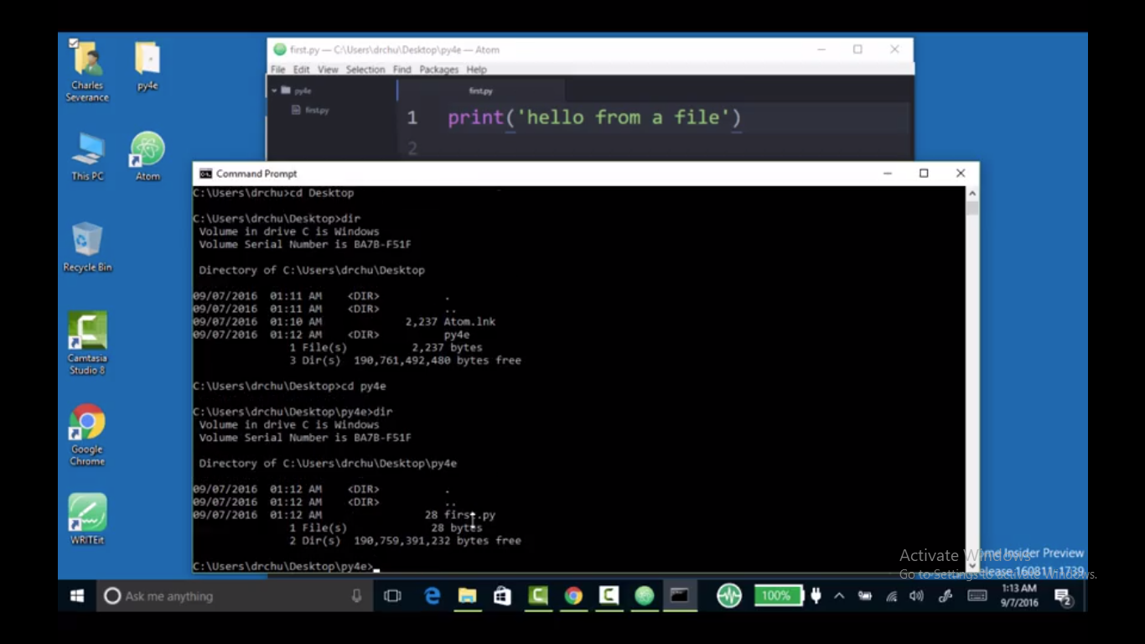

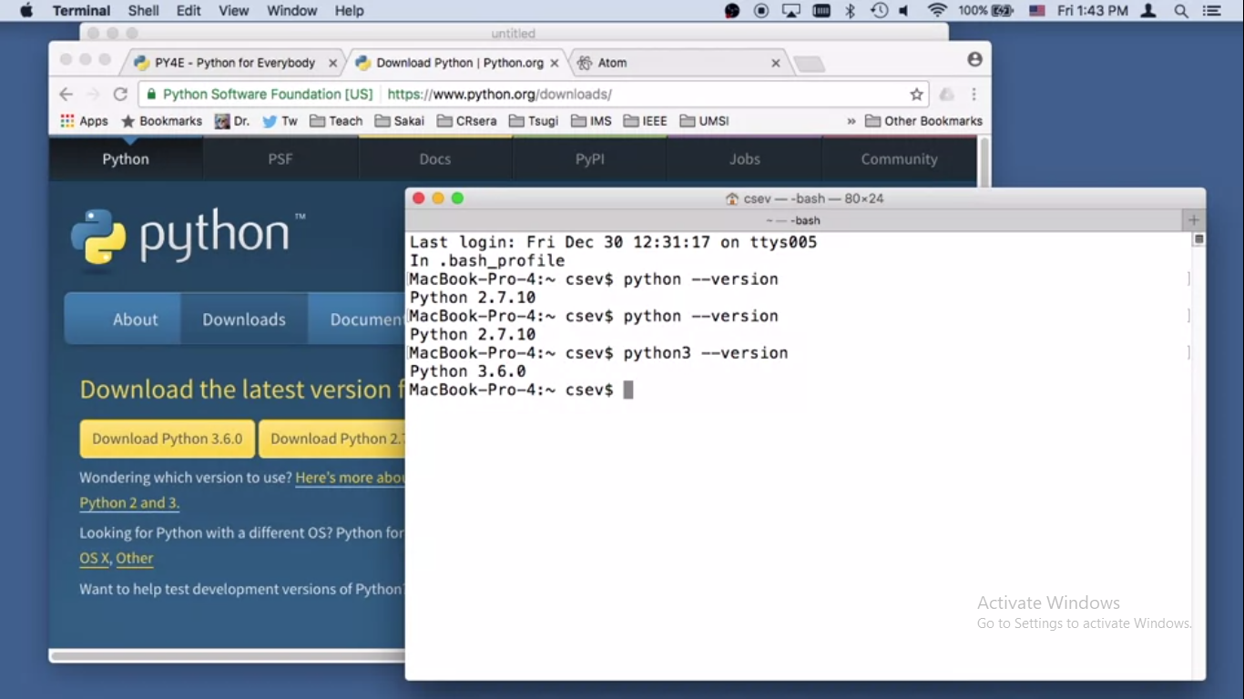

**Coding Challenges Details:**

# **Problem:** Write a java program to check for balanced parenthesis

Given an expression string exp. Examine whether the pairs and the orders of “{“,”}”,”(“,”)”,”[“,”]” are correct in exp.  
For example, the program should print 'balanced' for exp = “[()]{}{()()}” and 'not balanced' for exp = “[(])”

**Input:**  
Input consists of a string of expression, in a separate line.

**Output:**  
Print 'balanced' without quotes if the pair of parenthesis is balanced else print 'not balanced' in a separate line.

**Example:**  
Input:  
{([])}  
()  
([]

Output:  
balanced  
balanced  
not balanced

**Solution:** Uploaded it in GitHub

